Date:30.08.2022

**Final Year B. Tech., Sem VII 2021-22**

**High Performance Computing Lab**

**Assignment submission**

**PRN No: 2019BTECS00064**

**Full name: Kunal Santosh Kadam**

**Batch: B3**

**Assignment: 1**

**Title of assignment: Use of OpenMP in C**

1. Write a program that prints Hello World using OpenMP

Ans:

**Code:**

#include<omp.h>

#include<bits/stdc++.h>

int main(int argc, char* argv[])

{

#pragma omp parallel

{

printf("Thread No. %d Hello World\n", omp_get_thread_num());

}

return 0;

}

**Output:**

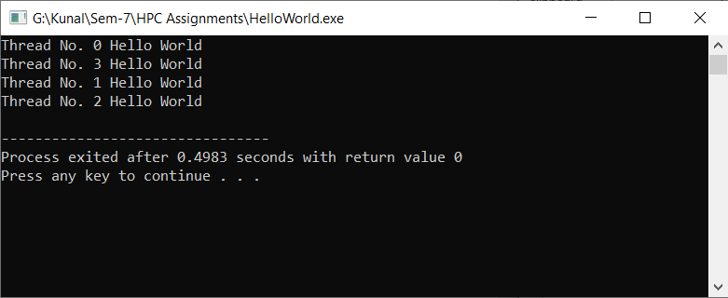

1. Write a program that print the square an their sum using the OpenMP

Ans:

**Code:**

#include<omp.h>

#include<bits/stdc++.h>

static int sum = 0;

int main()

{

#pragma omp parallel

{

for(int i = 1;i <= 100;i++)

{

if(i % 4 == omp_get_thread_num())

{

printf("Thread No. %d Number: %d Square: %d \n",omp_get_thread_num(), i , i*i);

sum += i*i;

printf("Sum is %d \n" ,sum);

}

}

}

return 0;

}

**Output:**

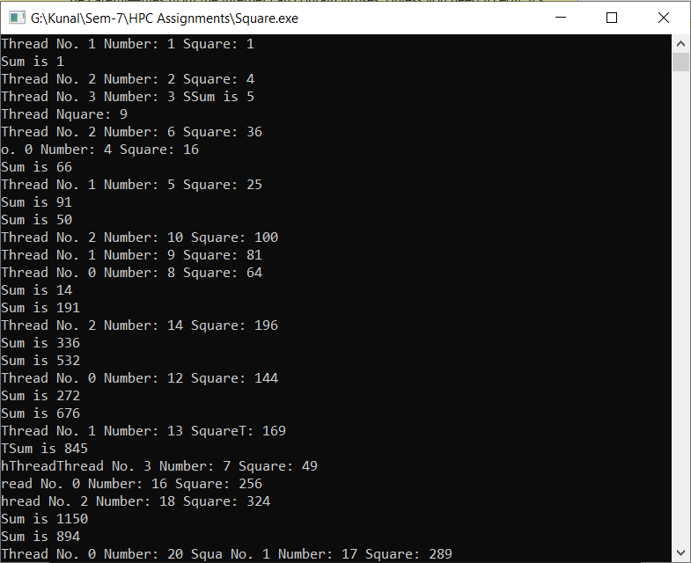

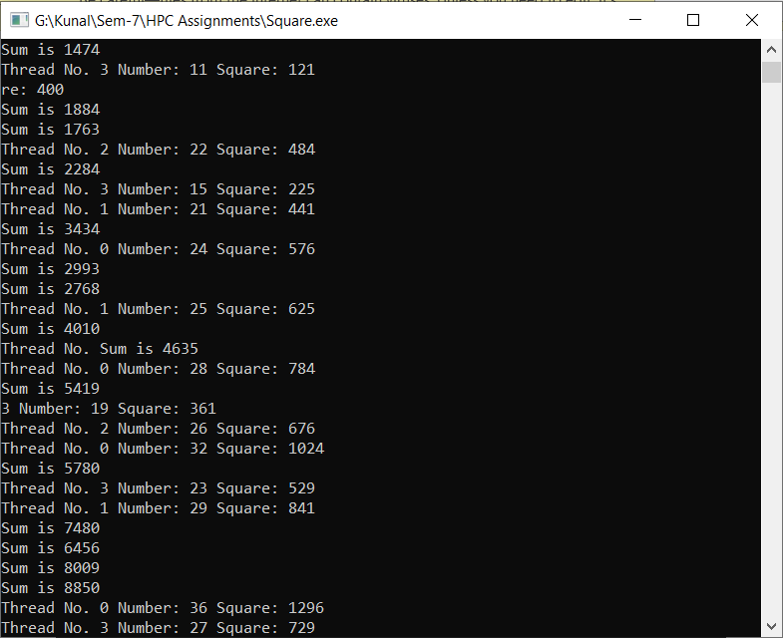

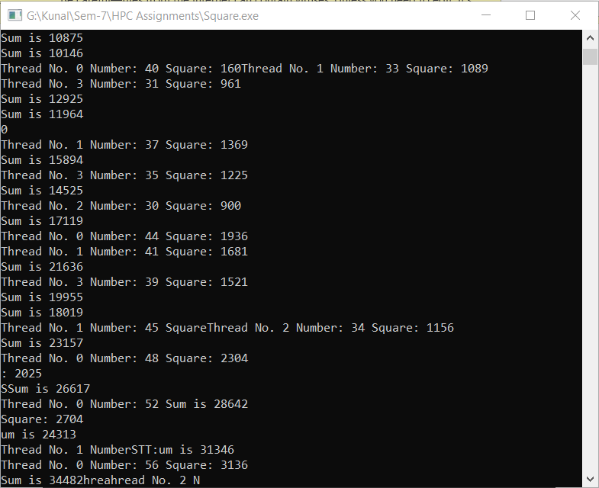

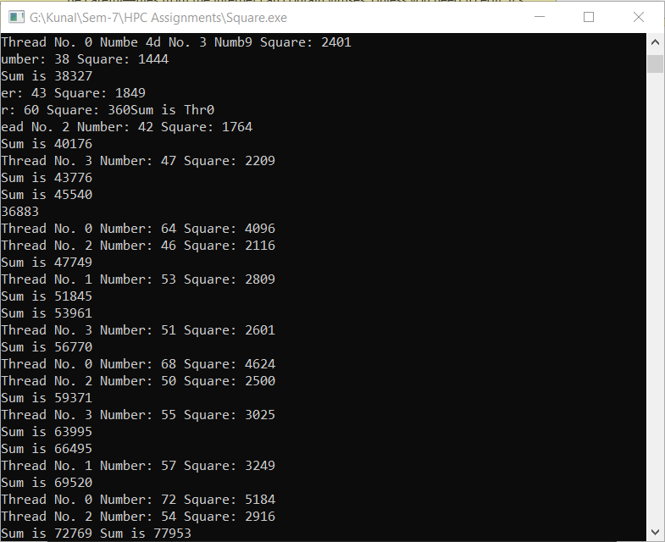

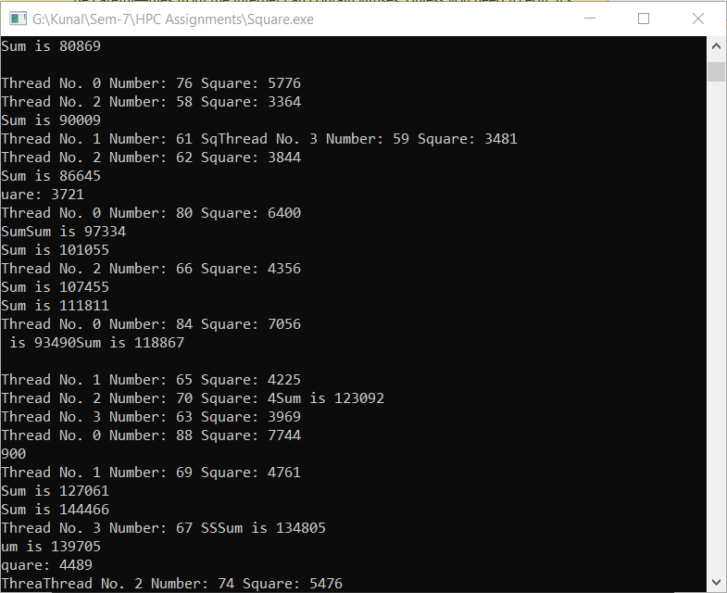

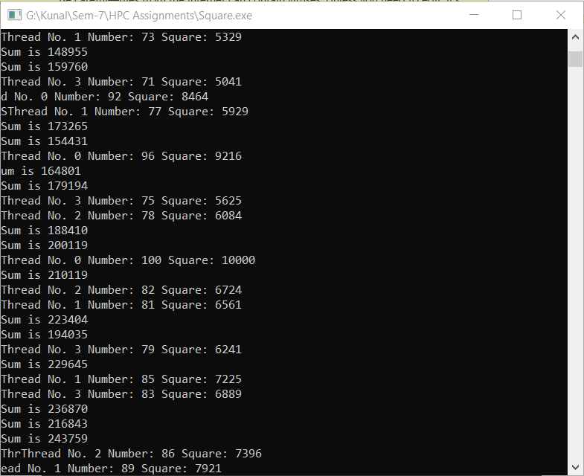

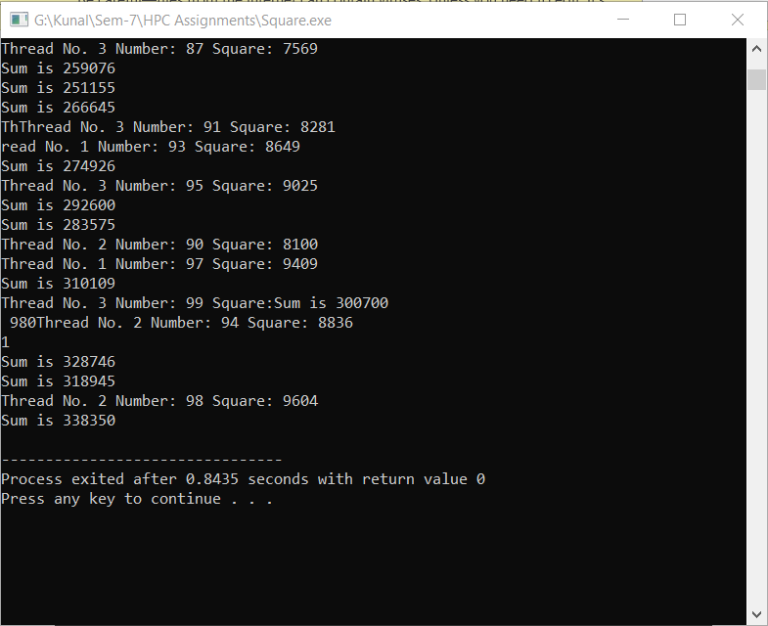

1. Write serial and parallel program and check their time for the execution

Ans:

**Serial Code:**

#include<bits/stdc++.h>

#include<omp.h>

int main()

{

long long sum =0 ;

double inTime = omp_get_wtime();

int i;

for(i=1;i <= 100000000;i++)

sum += (i*i);

double outTime = omp_get_wtime();

double expcTime = outTime - inTime;

printf("Time required for Execution in Serial: %f\n", expcTime);

printf("Answer is : %lld",sum);

return 0;

}

**Output:**

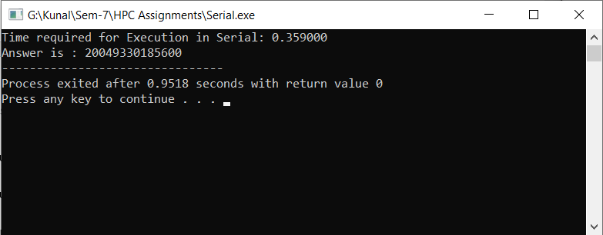

**Parallel Code:**

#include<bits/stdc++.h>

#include<omp.h>

int main()

{

long long sum = 0;

double getInTime = omp_get_wtime();

#pragma omp parallel for reduction(+ : sum)

for (int i=1;i <= 100000000; i++)

sum += i*i;

double getOutTime = omp_get_wtime();

double exptTime= getOutTime - getInTime;

printf("Time required for Execution in Parallel: %f\n", exptTime);

printf("Answer is: %lld", sum);

return 0;

}

**Output:**

